>> git clone https://github.com/commithouse/radar-combustivel-fake-data-generator.git

>> Resultado esperado:
PS C:\Users\caioa\Documents\projetos\fiap> git clone https://github.com/commithouse/radar-combustivel-fake-data-generator.git
Cloning into 'radar-combustivel-fake-data-generator'...
remote: Enumerating objects: 6, done.
remote: Counting objects: 100% (6/6), done.
remote: Compressing objects: 100% (5/5), done.
remote: Total 6 (delta 0), reused 6 (delta 0), pack-reused 0 (from 0)
Receiving objects: 100% (6/6), 5.19 KiB | 531.00 KiB/s, done.

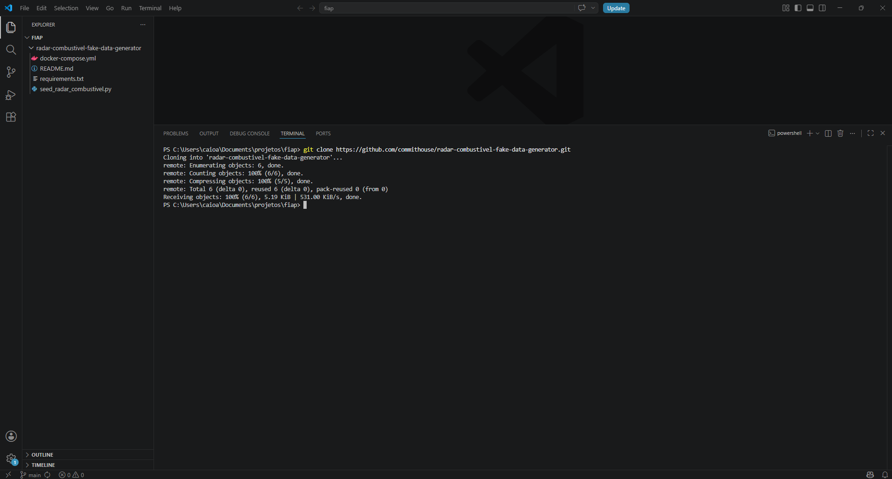

Abrir o Docker Desktop
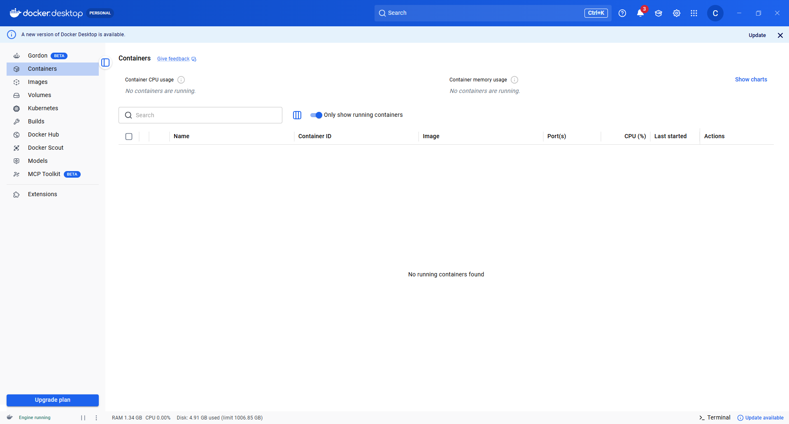
>> docker compose up -d
>> Resultado esperado:
PS C:\Users\caioa\Documents\projetos\fiap\radar-combustivel-fake-data-generator> docker compose up -d
[+] up 6/6
✔ Network radar-combustivel-fake-data-generator_default Created 0.0ss
✔ Container radar-combustivel-redis Healthy 11.5s
✔ Container radar-combustivel-mongo Healthy 12.0s
✔ Container lab-streamlit Started 12.3s
✔ Container radar-combustivel-mongo-init Started 12.2s
✔ Container lab-app Started

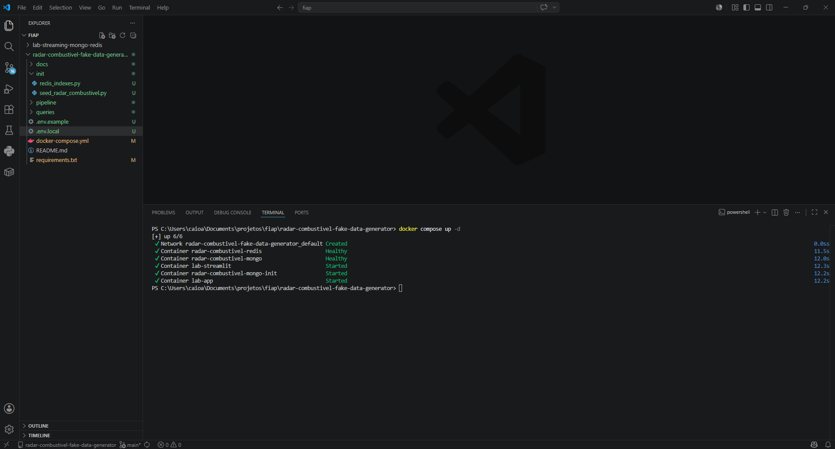

>> pip install -r requirements.txt
Collecting pymongo>=4.6.0 (from -r .\requirements.txt (line 1))
Using cached pymongo-4.17.0-cp313-cp313-win_amd64.whl.metadata (10 kB)
Collecting redis>=5.0.0 (from -r .\requirements.txt (line 2))
Using cached redis-7.4.0-py3-none-any.whl.metadata (12 kB)
Collecting Faker>=24.0.0 (from -r .\requirements.txt (line 3))
Downloading faker-40.18.0-py3-none-any.whl.metadata (16 kB)
Collecting python-dotenv>=1.0.0 (from -r .\requirements.txt (line 4))
Using cached python_dotenv-1.2.2-py3-none-any.whl.metadata (27 kB)
Collecting streamlit (from -r .\requirements.txt (line 5))
Using cached streamlit-1.57.0-py3-none-any.whl.metadata (9.6 kB)
Collecting plotly (from -r .\requirements.txt (line 7))
Using cached plotly-6.7.0-py3-none-any.whl.metadata (8.6 kB)
Collecting pandas (from -r .\requirements.txt (line 8))
Downloading pandas-3.0.3-cp313-cp313-win_amd64.whl.metadata (19 kB)
Requirement already satisfied: dnspython<3.0.0,>=2.6.1 in C:\Users\caioa\AppData\Local\Programs\Python\Python313\Lib\site-packages (from pymongo>=4.6.0->-r .\requirements.txt (line 1)) (2.8.0)
Requirement already satisfied: tzdata in C:\Users\caioa\AppData\Local\Programs\Python\Python313\Lib\site-packages (from Faker>=24.0.0->-r .\requirements.txt (line 3)) (2026.2)
Requirement already satisfied: altair!=5.4.0,!=5.4.1,<7,>=4.0 in C:\Users\caioa\AppData\Local\Programs\Python\Python313\Lib\site-packages (from streamlit->-r .\requirements.txt (line 5)) (6.1.0)
Requirement already satisfied: blinker<2,>=1.5.0 in C:\Users\caioa\AppData\Local\Programs\Python\Python313\Lib\site-packages (from streamlit->-r .\requirements.txt (line 5)) (1.9.0)
Requirement already satisfied: cachetools<8,>=5.5 in C:\Users\caioa\AppData\Local\Programs\Python\Python313\Lib\site-packages (from streamlit->-r .\requirements.txt (line 5)) (7.1.1)
Requirement already satisfied: click<9,>=7.0 in C:\Users\caioa\AppData\Local\Programs\Python\Python313\Lib\site-packages (from streamlit->-r .\requirements.txt (line 5)) (8.3.3)
Requirement already satisfied: gitpython!=3.1.19,<4,>=3.0.7 in C:\Users\caioa\AppData\Local\Programs\Python\Python313\Lib\site-packages (from streamlit->-r .\requirements.txt (line 5)) (3.1.50)
Requirement already satisfied: numpy<3,>=1.23 in C:\Users\caioa\AppData\Local\Programs\Python\Python313\Lib\site-packages (from streamlit->-r .\requirements.txt (line 5)) (2.4.4)
Requirement already satisfied: packaging>=20 in C:\Users\caioa\AppData\Local\Programs\Python\Python313\Lib\site-packages (from streamlit->-r .\requirements.txt (line 5)) (26.2)
Requirement already satisfied: pillow<13,>=7.1.0 in C:\Users\caioa\AppData\Local\Programs\Python\Python313\Lib\site-packages (from streamlit->-r .\requirements.txt (line 5)) (12.2.0)
Requirement already satisfied: pydeck<1,>=0.8.0b4 in C:\Users\caioa\AppData\Local\Programs\Python\Python313\Lib\site-packages (from streamlit->-r .\requirements.txt (line 5)) (0.9.2)
Requirement already satisfied: protobuf<8,>=3.20 in C:\Users\caioa\AppData\Local\Programs\Python\Python313\Lib\site-packages (from streamlit->-r .\requirements.txt (line 5)) (7.34.1)
Requirement already satisfied: pyarrow>=7.0 in C:\Users\caioa\AppData\Local\Programs\Python\Python313\Lib\site-packages (from streamlit->-r .\requirements.txt (line 5)) (24.0.0)
Requirement already satisfied: requests<3,>=2.27 in C:\Users\caioa\AppData\Local\Programs\Python\Python313\Lib\site-packages (from streamlit->-r .\requirements.txt (line 5)) (2.33.1)
Requirement already satisfied: tenacity<10,>=8.1.0 in C:\Users\caioa\AppData\Local\Programs\Python\Python313\Lib\site-packages (from streamlit->-r .\requirements.txt (line 5)) (9.1.4)
Requirement already satisfied: toml<2,>=0.10.1 in C:\Users\caioa\AppData\Local\Programs\Python\Python313\Lib\site-packages (from streamlit->-r .\requirements.txt (line 5)) (0.10.2)
Requirement already satisfied: typing-extensions<5,>=4.10.0 in C:\Users\caioa\AppData\Local\Programs\Python\Python313\Lib\site-packages (from streamlit->-r .\requirements.txt (line 5)) (4.15.0)
Requirement already satisfied: starlette>=0.40.0 in C:\Users\caioa\AppData\Local\Programs\Python\Python313\Lib\site-packages (from streamlit->-r .\requirements.txt (line 5)) (1.0.0)
Requirement already satisfied: uvicorn>=0.30.0 in C:\Users\caioa\AppData\Local\Programs\Python\Python313\Lib\site-packages (from streamlit->-r .\requirements.txt (line 5)) (0.46.0)
Requirement already satisfied: httptools>=0.6.3 in C:\Users\caioa\AppData\Local\Programs\Python\Python313\Lib\site-packages (from streamlit->-r .\requirements.txt (line 5)) (0.7.1)
Requirement already satisfied: anyio>=4.0.0 in C:\Users\caioa\AppData\Local\Programs\Python\Python313\Lib\site-packages (from streamlit->-r .\requirements.txt (line 5)) (4.13.0)
Requirement already satisfied: python-multipart>=0.0.10 in C:\Users\caioa\AppData\Local\Programs\Python\Python313\Lib\site-packages (from streamlit->-r .\requirements.txt (line 5)) (0.0.27)
Requirement already satisfied: websockets>=12.0.0 in C:\Users\caioa\AppData\Local\Programs\Python\Python313\Lib\site-packages (from streamlit->-r .\requirements.txt (line 5)) (16.0)
Requirement already satisfied: itsdangerous>=2.1.2 in C:\Users\caioa\AppData\Local\Programs\Python\Python313\Lib\site-packages (from streamlit->-r .\requirements.txt (line 5)) (2.2.0)
Requirement already satisfied: watchdog<7,>=2.1.5 in C:\Users\caioa\AppData\Local\Programs\Python\Python313\Lib\site-packages (from streamlit->-r .\requirements.txt (line 5)) (6.0.0)
Requirement already satisfied: python-dateutil>=2.8.2 in C:\Users\caioa\AppData\Local\Programs\Python\Python313\Lib\site-packages (from pandas->-r .\requirements.txt (line 8)) (2.9.0.post0)
Requirement already satisfied: jinja2 in C:\Users\caioa\AppData\Local\Programs\Python\Python313\Lib\site-packages (from altair!=5.4.0,!=5.4.1,<7,>=4.0->streamlit->-r .\requirements.txt (line 5)) (3.1.6)
Requirement already satisfied: jsonschema>=3.0 in C:\Users\caioa\AppData\Local\Programs\Python\Python313\Lib\site-packages (from altair!=5.4.0,!=5.4.1,<7,>=4.0->streamlit->-r .\requirements.txt (line 5)) (4.26.0)
Requirement already satisfied: narwhals>=2.4.0 in C:\Users\caioa\AppData\Local\Programs\Python\Python313\Lib\site-packages (from altair!=5.4.0,!=5.4.1,<7,>=4.0->streamlit->-r .\requirements.txt (line 5)) (2.21.0)
Requirement already satisfied: colorama in C:\Users\caioa\AppData\Local\Programs\Python\Python313\Lib\site-packages (from click<9,>=7.0->streamlit->-r .\requirements.txt (line 5)) (0.4.6)
Requirement already satisfied: gitdb<5,>=4.0.1 in C:\Users\caioa\AppData\Local\Programs\Python\Python313\Lib\site-packages (from gitpython!=3.1.19,<4,>=3.0.7->streamlit->-r .\requirements.txt (line 5)) (4.0.12)
Requirement already satisfied: smmap<6,>=3.0.1 in C:\Users\caioa\AppData\Local\Programs\Python\Python313\Lib\site-packages (from gitdb<5,>=4.0.1->gitpython!=3.1.19,<4,>=3.0.7->streamlit->-r .\requirements.txt (line 5)) (5.0.3)
Requirement already satisfied: charset_normalizer<4,>=2 in C:\Users\caioa\AppData\Local\Programs\Python\Python313\Lib\site-packages (from requests<3,>=2.27->streamlit->-r .\requirements.txt (line 5)) (3.4.7)
Requirement already satisfied: idna<4,>=2.5 in C:\Users\caioa\AppData\Local\Programs\Python\Python313\Lib\site-packages (from requests<3,>=2.27->streamlit->-r .\requirements.txt (line 5)) (3.13)
Requirement already satisfied: urllib3<3,>=1.26 in C:\Users\caioa\AppData\Local\Programs\Python\Python313\Lib\site-packages (from requests<3,>=2.27->streamlit->-r .\requirements.txt (line 5)) (2.7.0)
Requirement already satisfied: certifi>=2023.5.7 in C:\Users\caioa\AppData\Local\Programs\Python\Python313\Lib\site-packages (from requests<3,>=2.27->streamlit->-r .\requirements.txt (line 5)) (2026.4.22)
Requirement already satisfied: MarkupSafe>=2.0 in C:\Users\caioa\AppData\Local\Programs\Python\Python313\Lib\site-packages (from jinja2->altair!=5.4.0,!=5.4.1,<7,>=4.0->streamlit->-r .\requirements.txt (line 5)) (3.0.3)
Requirement already satisfied: attrs>=22.2.0 in C:\Users\caioa\AppData\Local\Programs\Python\Python313\Lib\site-packages (from jsonschema>=3.0->altair!=5.4.0,!=5.4.1,<7,>=4.0->streamlit->-r .\requirements.txt (line 5)) (26.1.0)
Requirement already satisfied: jsonschema-specifications>=2023.03.6 in C:\Users\caioa\AppData\Local\Programs\Python\Python313\Lib\site-packages (from jsonschema>=3.0->altair!=5.4.0,!=5.4.1,<7,>=4.0->streamlit->-r .\requirements.txt (line 5)) (2025.9.1)
Requirement already satisfied: referencing>=0.28.4 in C:\Users\caioa\AppData\Local\Programs\Python\Python313\Lib\site-packages (from jsonschema>=3.0->altair!=5.4.0,!=5.4.1,<7,>=4.0->streamlit->-r .\requirements.txt (line 5)) (0.37.0)
Requirement already satisfied: rpds-py>=0.25.0 in C:\Users\caioa\AppData\Local\Programs\Python\Python313\Lib\site-packages (from jsonschema>=3.0->altair!=5.4.0,!=5.4.1,<7,>=4.0->streamlit->-r .\requirements.txt (line 5)) (0.30.0)
Requirement already satisfied: six>=1.5 in C:\Users\caioa\AppData\Local\Programs\Python\Python313\Lib\site-packages (from python-dateutil>=2.8.2->pandas->-r .\requirements.txt (line 8)) (1.17.0)
Requirement already satisfied: h11>=0.8 in C:\Users\caioa\AppData\Local\Programs\Python\Python313\Lib\site-packages (from uvicorn>=0.30.0->streamlit->-r .\requirements.txt (line 5)) (0.16.0)
Using cached pymongo-4.17.0-cp313-cp313-win_amd64.whl (972 kB)
Using cached redis-7.4.0-py3-none-any.whl (409 kB)
Downloading faker-40.18.0-py3-none-any.whl (2.0 MB)
━━━━━━━━━━━━━━━━━━━━━━━━━━━━━━━━━━━━━━━━ 2.0/2.0 MB 10.1 MB/s 0:00:00
Using cached python_dotenv-1.2.2-py3-none-any.whl (22 kB)
Using cached streamlit-1.57.0-py3-none-any.whl (9.2 MB)
Downloading pandas-3.0.3-cp313-cp313-win_amd64.whl (9.8 MB)
━━━━━━━━━━━━━━━━━━━━━━━━━━━━━━━━━━━━━━━━ 9.8/9.8 MB 8.4 MB/s 0:00:01
Using cached plotly-6.7.0-py3-none-any.whl (9.9 MB)
Installing collected packages: redis, python-dotenv, pymongo, plotly, Faker, pandas, streamlit
Successfully installed Faker-40.18.0 pandas-3.0.3 plotly-6.7.0 pymongo-4.17.0 python-dotenv-1.2.2 redis-7.4.0 streamlit-1.57.0

[notice] A new release of pip is available: 26.0.1 -> 26.1.1
[notice] To update, run: python.exe -m pip install --upgrade pip

>> python .\init\seed_radar_combustivel.py
>> Resultado esperado:
PS C:\Users\caioa\Documents\projetos\fiap\radar-combustivel-fake-data-generator> python .\init\seed_radar_combustivel.py
[CONFIG] DB: radar_combustivel | SEED: 42 | Batch: 5000
[CONFIG] Modo: SEED COMPLETO | Documentos: 100000
[CONECTADO] MongoDB em: mongodb://localhost:27017/?directConnection=true
[REPLICASET] Já inicializado
Gerando IDs de postos e documentos...
Inserindo postos...
postos: 5000 inseridos...
postos: 10000 inseridos...
postos: 15000 inseridos...
postos: 20000 inseridos...
postos: 25000 inseridos...
postos: 30000 inseridos...
postos: 35000 inseridos...
postos: 40000 inseridos...
postos: 45000 inseridos...
postos: 50000 inseridos...
postos: 55000 inseridos...
postos: 60000 inseridos...
postos: 65000 inseridos...
postos: 70000 inseridos...
postos: 75000 inseridos...
postos: 80000 inseridos...
postos: 85000 inseridos...
postos: 90000 inseridos...
postos: 95000 inseridos...
postos: 100000 inseridos...
Inserindo localizacoes_postos (1:1 com postos)...
localizacoes_postos: 5000 inseridos...
localizacoes_postos: 10000 inseridos...
localizacoes_postos: 15000 inseridos...
localizacoes_postos: 20000 inseridos...
localizacoes_postos: 25000 inseridos...
localizacoes_postos: 30000 inseridos...
localizacoes_postos: 35000 inseridos...
localizacoes_postos: 40000 inseridos...
localizacoes_postos: 45000 inseridos...
localizacoes_postos: 50000 inseridos...
localizacoes_postos: 55000 inseridos...
localizacoes_postos: 60000 inseridos...
localizacoes_postos: 65000 inseridos...
localizacoes_postos: 70000 inseridos...
localizacoes_postos: 75000 inseridos...
localizacoes_postos: 80000 inseridos...
localizacoes_postos: 85000 inseridos...
localizacoes_postos: 90000 inseridos...
localizacoes_postos: 95000 inseridos...
localizacoes_postos: 100000 inseridos...
Gerando e inserindo eventos_preco...
eventos_preco: 5000 inseridos...
eventos_preco: 10000 inseridos...
eventos_preco: 15000 inseridos...
eventos_preco: 20000 inseridos...
eventos_preco: 25000 inseridos...
eventos_preco: 30000 inseridos...
eventos_preco: 35000 inseridos...
eventos_preco: 40000 inseridos...
eventos_preco: 45000 inseridos...
eventos_preco: 50000 inseridos...
eventos_preco: 55000 inseridos...
eventos_preco: 60000 inseridos...
eventos_preco: 65000 inseridos...
eventos_preco: 70000 inseridos...
eventos_preco: 75000 inseridos...
eventos_preco: 80000 inseridos...
eventos_preco: 85000 inseridos...
eventos_preco: 90000 inseridos...
eventos_preco: 95000 inseridos...
eventos_preco: 100000 inseridos...
Gerando e inserindo buscas_usuarios...
buscas_usuarios: 5000 inseridos...
buscas_usuarios: 10000 inseridos...
buscas_usuarios: 15000 inseridos...
buscas_usuarios: 20000 inseridos...
buscas_usuarios: 25000 inseridos...
buscas_usuarios: 30000 inseridos...
buscas_usuarios: 35000 inseridos...
buscas_usuarios: 40000 inseridos...
buscas_usuarios: 45000 inseridos...
buscas_usuarios: 50000 inseridos...
buscas_usuarios: 55000 inseridos...
buscas_usuarios: 60000 inseridos...
buscas_usuarios: 65000 inseridos...
buscas_usuarios: 70000 inseridos...
buscas_usuarios: 75000 inseridos...
buscas_usuarios: 80000 inseridos...
buscas_usuarios: 85000 inseridos...
buscas_usuarios: 90000 inseridos...
buscas_usuarios: 95000 inseridos...
buscas_usuarios: 100000 inseridos...
Gerando e inserindo avaliacoes_interacoes...
avaliacoes_interacoes: 5000 inseridos...
avaliacoes_interacoes: 10000 inseridos...
avaliacoes_interacoes: 15000 inseridos...
avaliacoes_interacoes: 20000 inseridos...
avaliacoes_interacoes: 25000 inseridos...
avaliacoes_interacoes: 30000 inseridos...
avaliacoes_interacoes: 35000 inseridos...
avaliacoes_interacoes: 40000 inseridos...
avaliacoes_interacoes: 45000 inseridos...
avaliacoes_interacoes: 50000 inseridos...
avaliacoes_interacoes: 55000 inseridos...
avaliacoes_interacoes: 60000 inseridos...
avaliacoes_interacoes: 65000 inseridos...
avaliacoes_interacoes: 70000 inseridos...
avaliacoes_interacoes: 75000 inseridos...
avaliacoes_interacoes: 80000 inseridos...
avaliacoes_interacoes: 85000 inseridos...
avaliacoes_interacoes: 90000 inseridos...
avaliacoes_interacoes: 95000 inseridos...
avaliacoes_interacoes: 100000 inseridos...
Criando índices...
[SEED] Concluído. Total aproximado de documentos: 500000
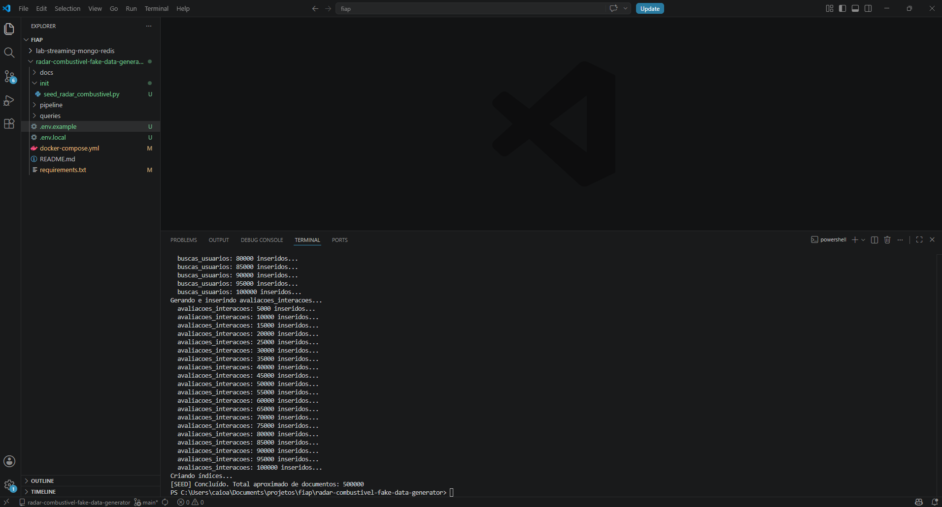

>> mongodb://localhost:27017/?directConnection=true
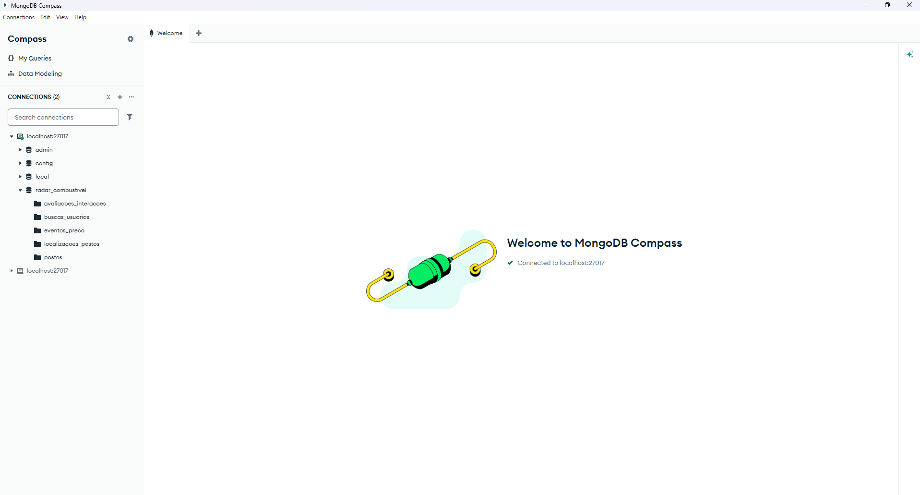
>> Bases de dados do Mongo DB
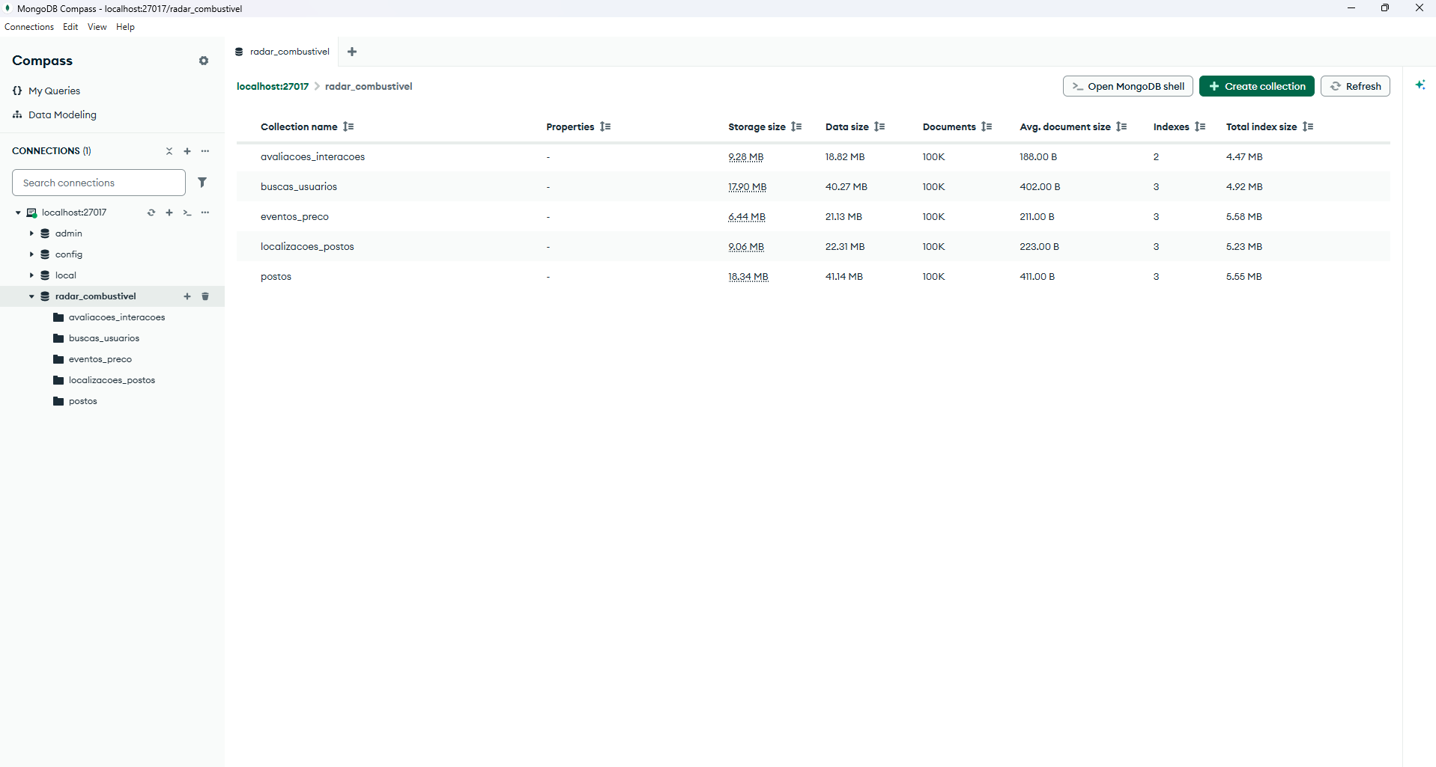
>> python init/redis_indexes.py
>> Resultados esperados:
PS C:\Users\caioa\Documents\projetos\fiap\radar-combustivel-fake-data-generator> python .\init\redis_indexes.py
[REDIS] Carregando 10000 postos...
[REDIS] Carregando 92155 preços...
[REDIS] idx:postos criado com 10000 postos e 92155 preços em cache.
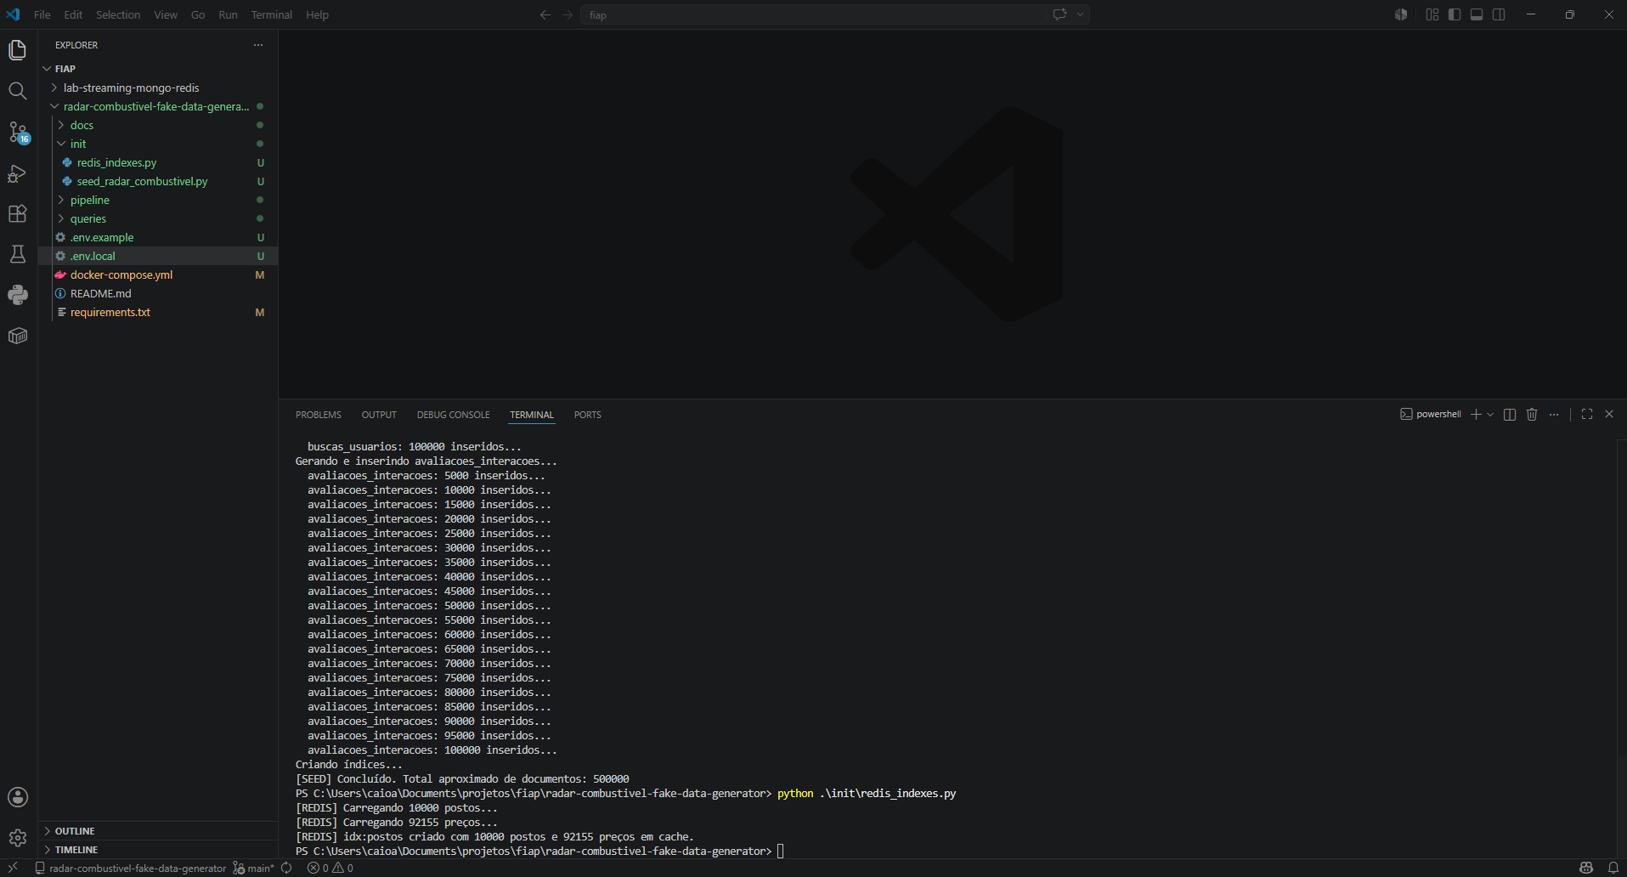

>> python .\pipeline\pipeline_radar.py
Resultado esperado:
PS C:\Users\caioa\Documents\projetos\fiap\radar-combustivel-fake-data-generator> python .\pipeline\pipeline_radar.py
22:20:11 [INFO] Conectando MongoDB: mongodb://localhost:27017/?directConnection=true / radar_combustivel
22:20:11 [INFO] Conectando Redis: localhost:6379
22:20:11 [INFO] ==================================================
22:20:11 [INFO] BATCH INICIO — MongoDB → Redis
22:20:11 [INFO] ==================================================
22:21:09 [INFO] [batch_postos] 100000 postos → HASH posto:{id} + GEO geo:postos
22:22:31 [INFO] [batch_rankings_preco] 92155 entradas → ZSET ranking:preco:*
22:22:45 [INFO] [batch_rankings_buscas] 29226 cidades → ZSET ranking:buscas
22:23:28 [INFO] [batch_rankings_variacao] 92155 entradas → ZSET ranking:variacao:*
22:23:28 [INFO] [batch_stats_globais] stats:preco_medio atualizado (6 combustiveis)
22:23:39 [INFO] [batch_timeseries] 5438 pontos → TS ts:preco_avg:*
22:23:39 [INFO] BATCH CONCLUIDO em 208.3s
22:23:39 [INFO] ==================================================
22:23:39 [INFO] [STREAM] Aguardando eventos em eventos_preco (Change Stream)...
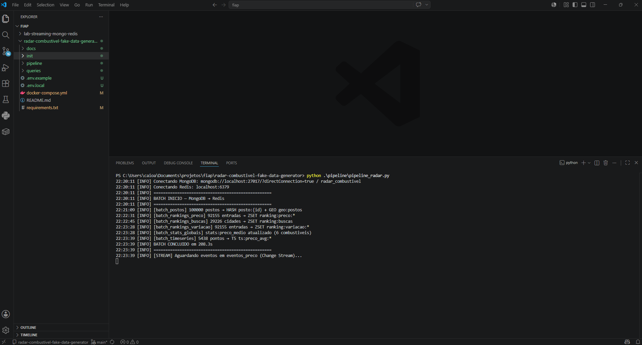

>> Dashboard: http://localhost:8501
Visão: Resumo Global
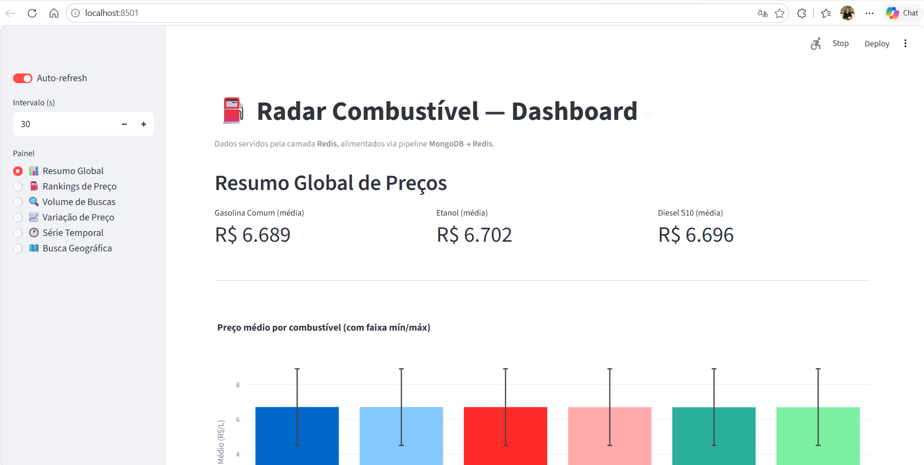
Visão: Ranking de Preço:
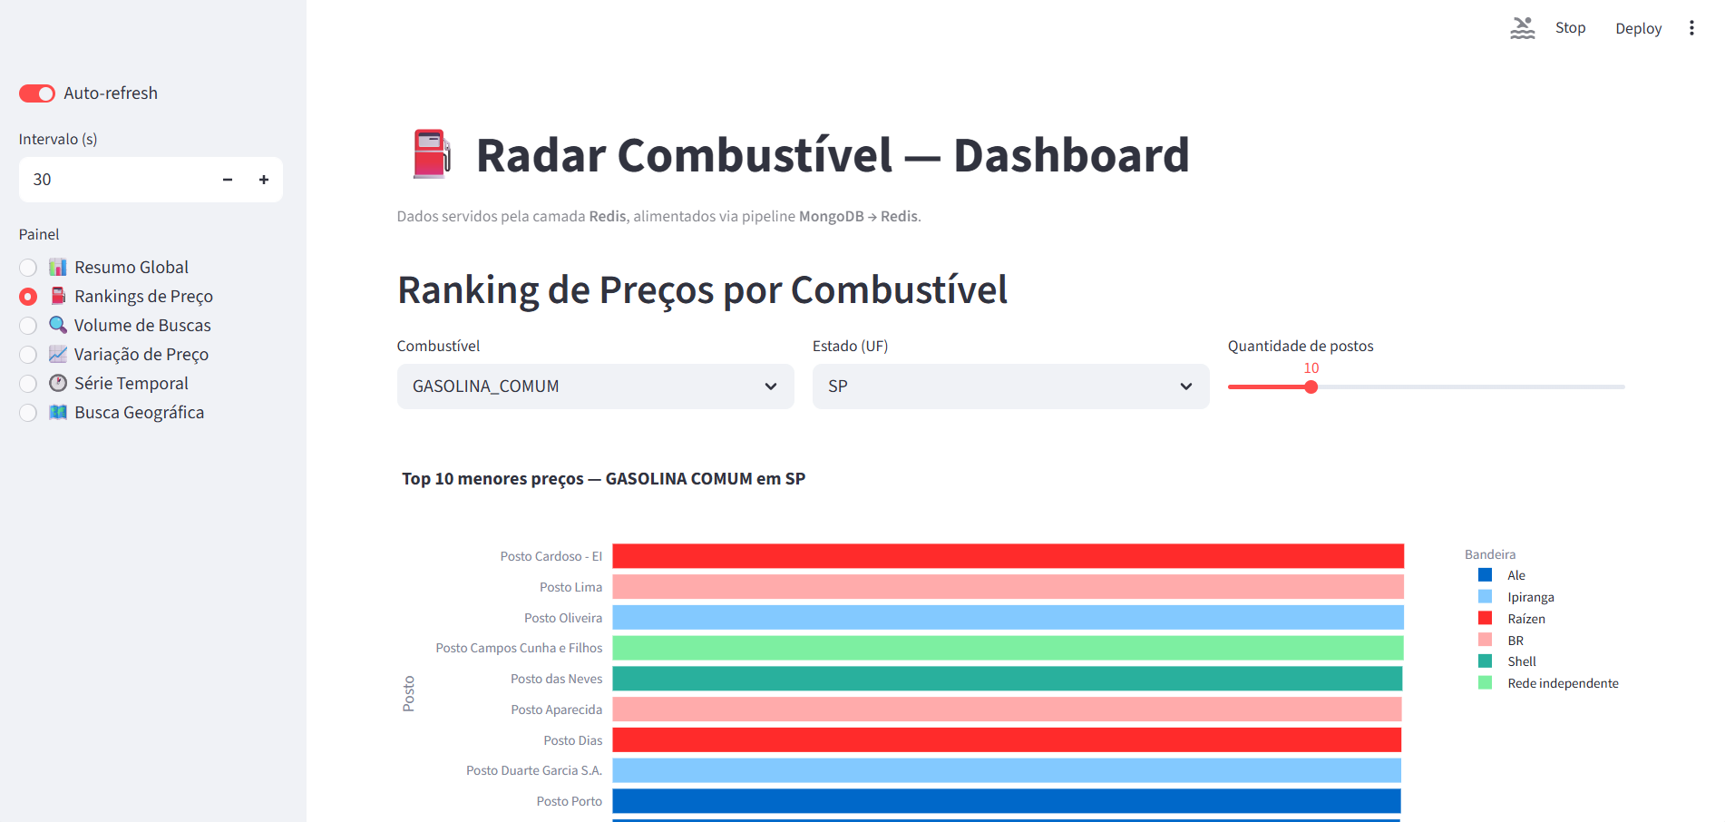
Visão: Volume de Buscas:
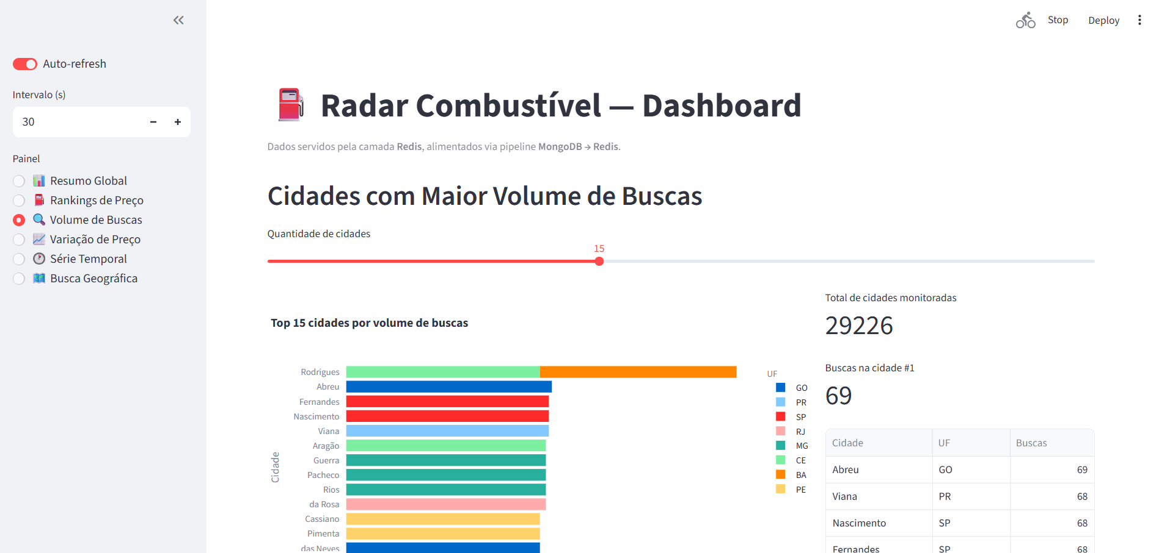
Visão: Variação de Preço:
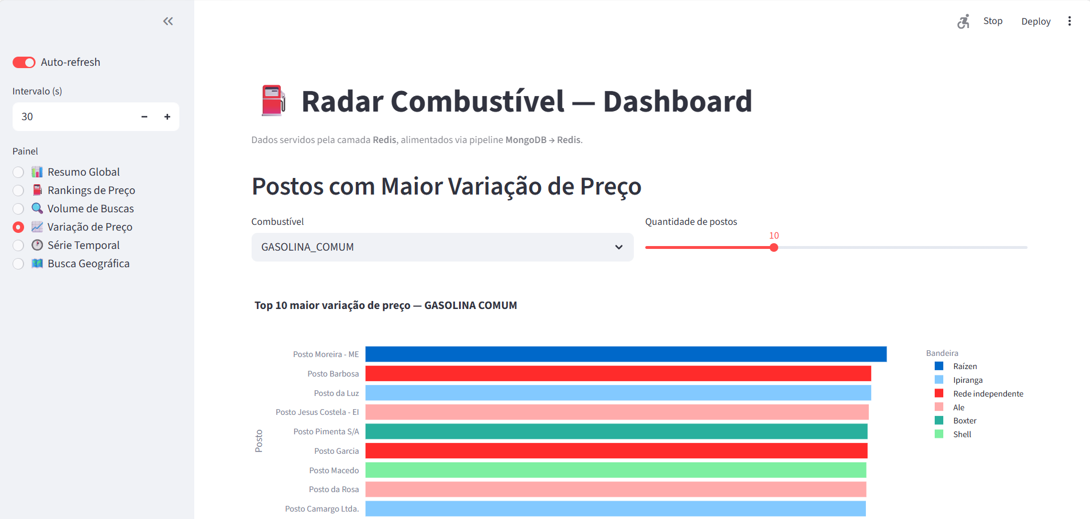
Visão: Série Temporal:
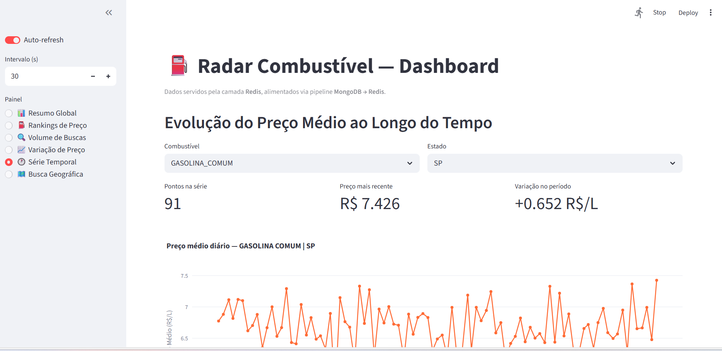
Visão: Busca geográfica
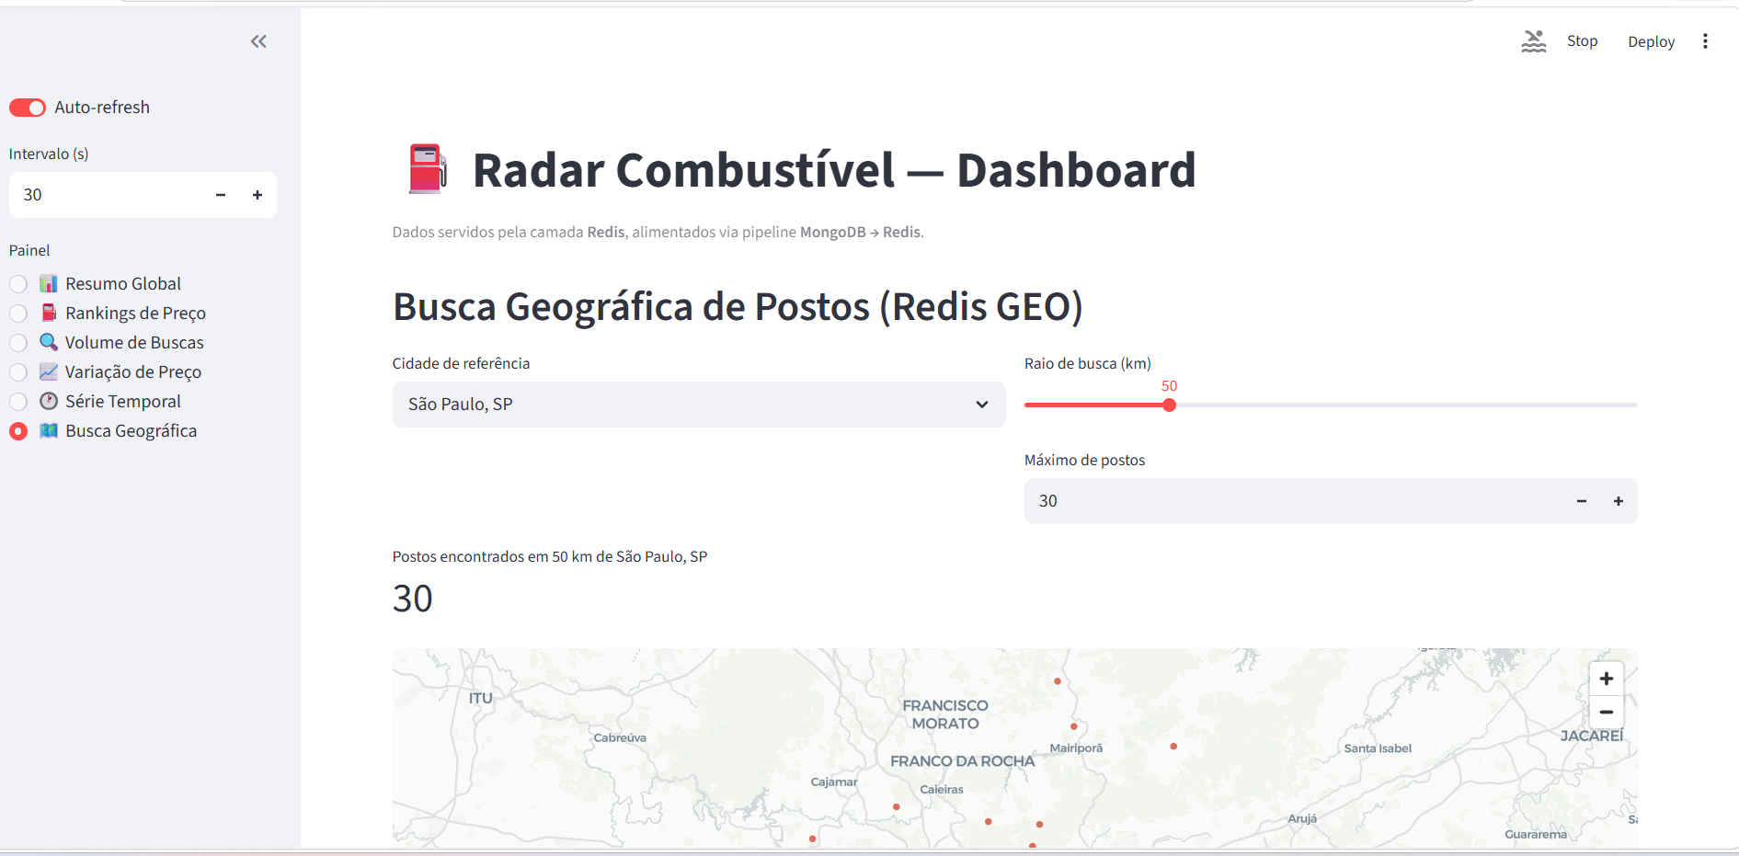

Redis insgihts
# Top 10 postos mais baratos (Gasolina Comum em SP)
ZRANGE ranking:preco:GASOLINA_COMUM:SP 0 9 WITHSCORES
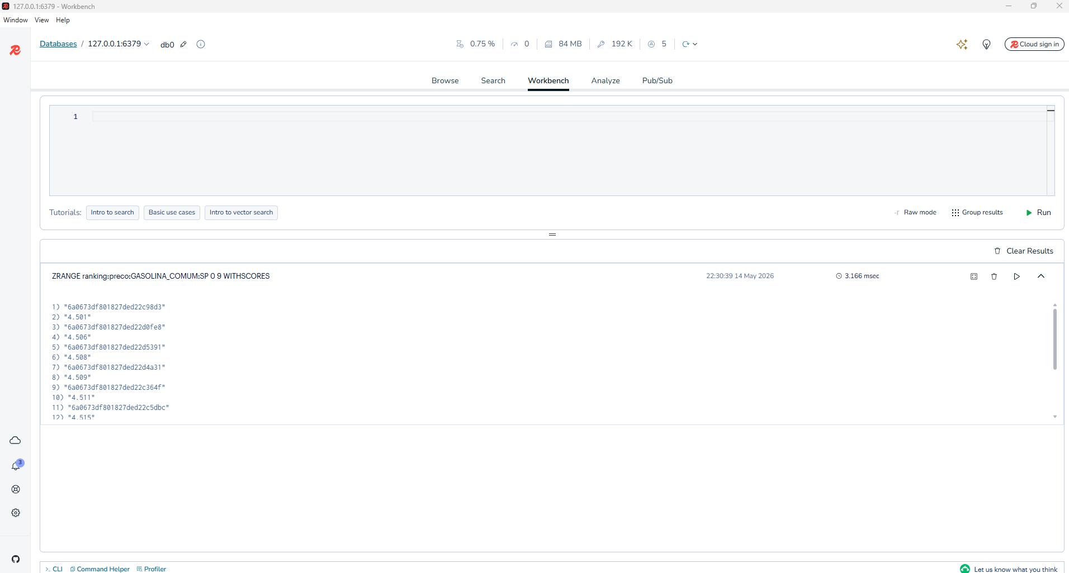

# Top 10 cidades com mais buscas
ZREVRANGE ranking:buscas 0 9 WITHSCORES
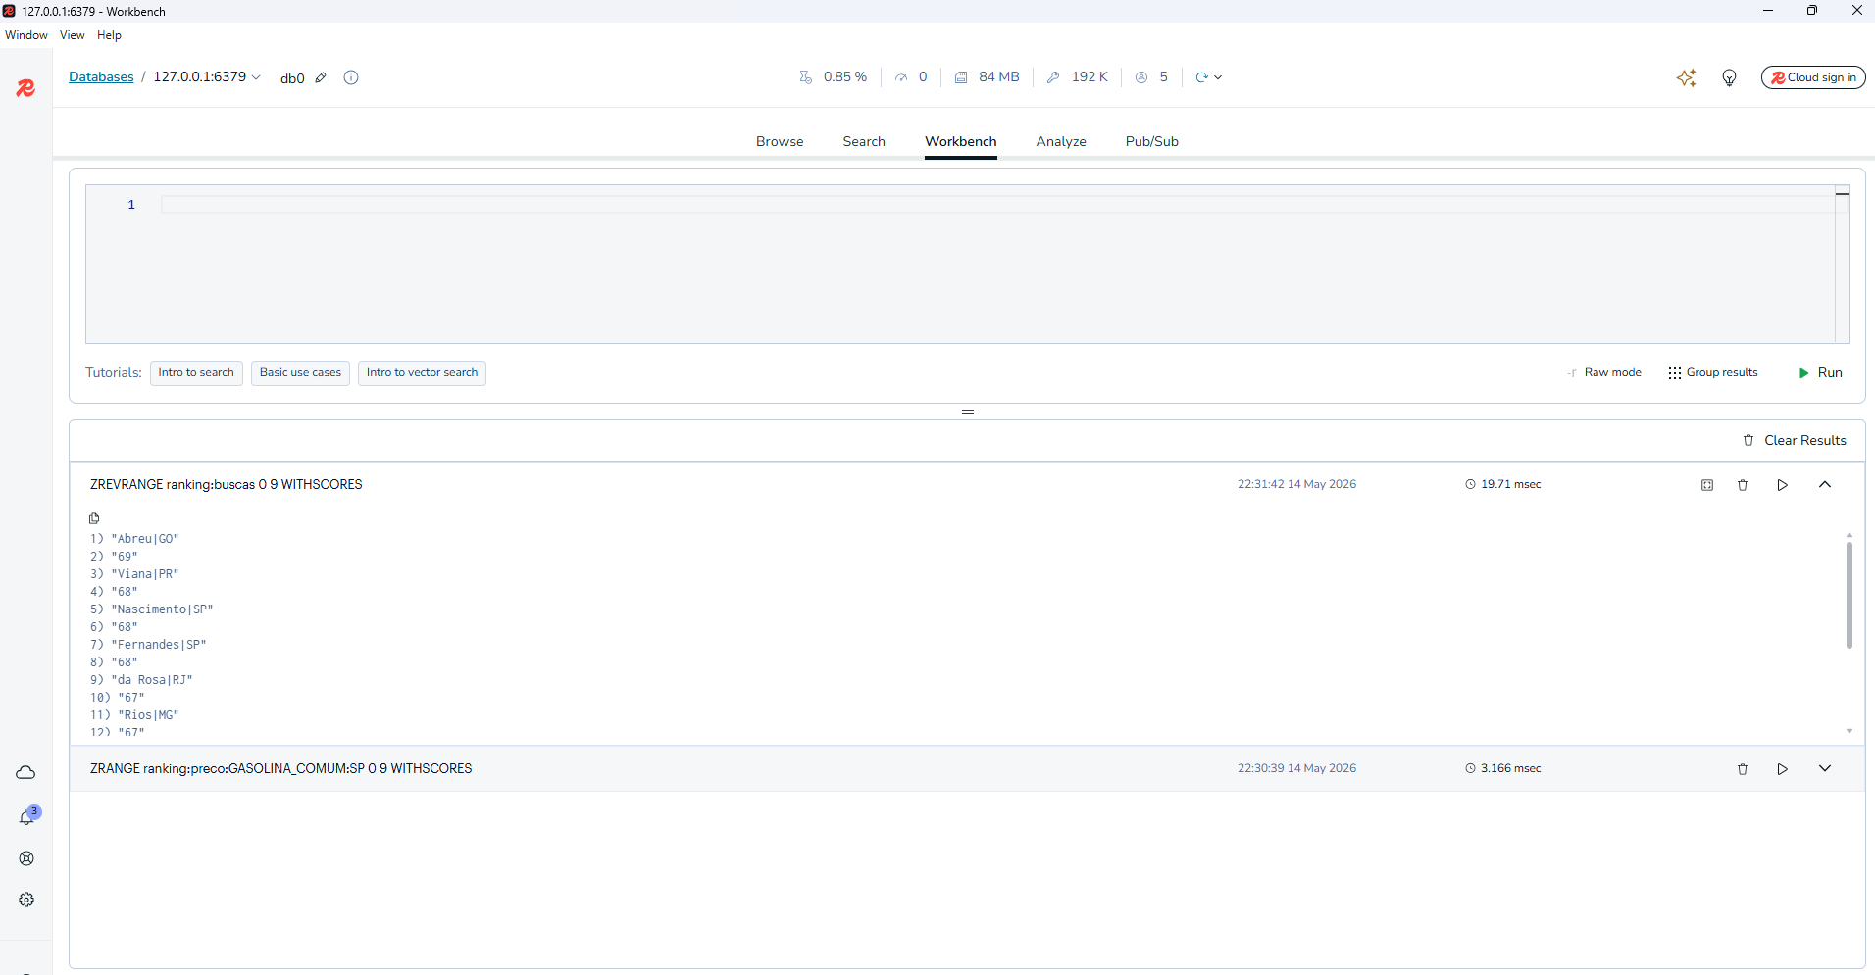

# Preço médio global por combustível
HGETALL stats:preco_medio
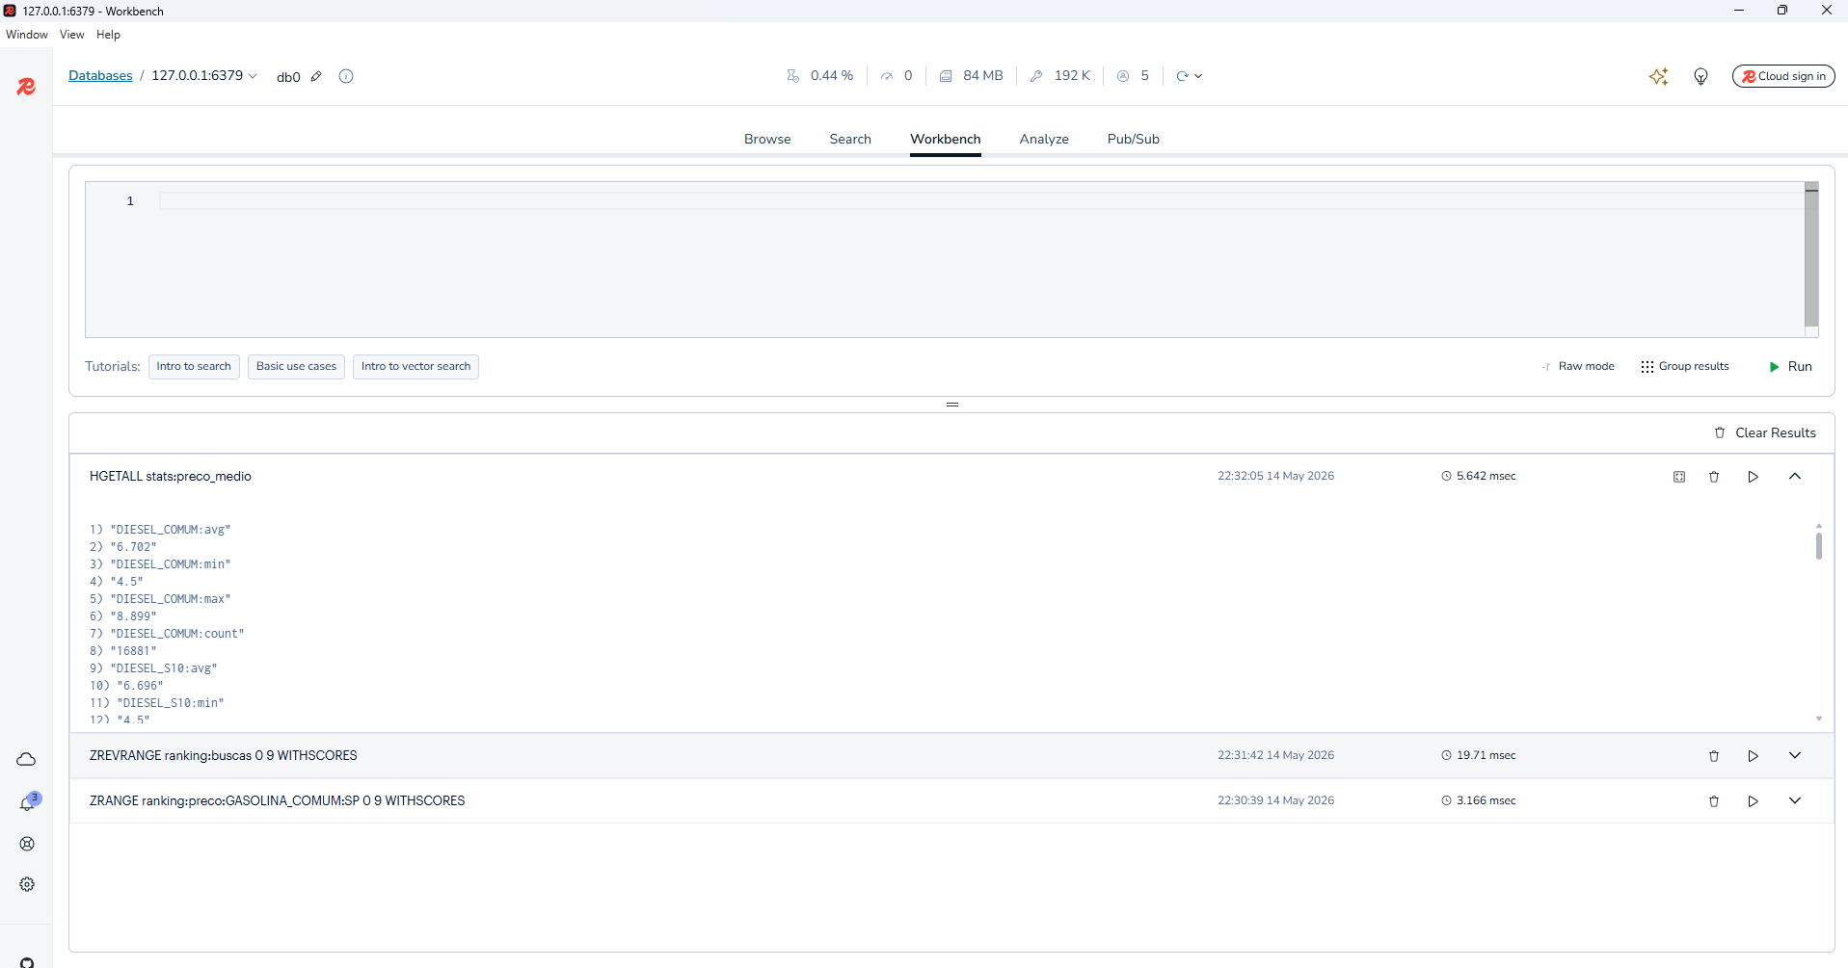
# Postos em raio de 50 km de São Paulo
GEOSEARCH geo:postos FROMLONLAT -46.6333 -23.5505 BYRADIUS 50 km ASC COUNT 10
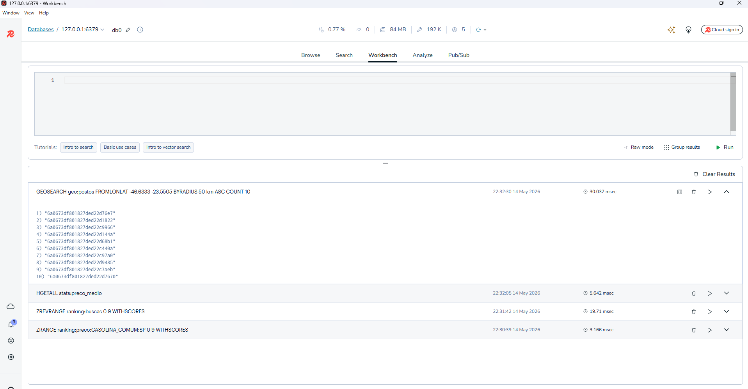
# Série temporal de preço médio (Gasolina Comum / SP)
TS.RANGE ts:preco_avg:GASOLINA_COMUM:SP - +
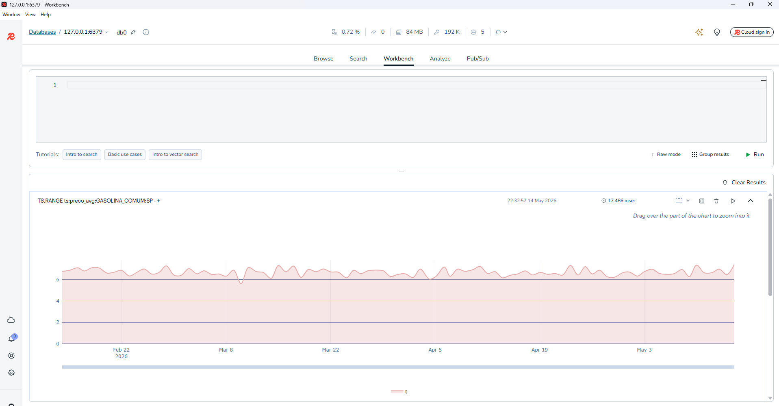

>>docker compose down -v

